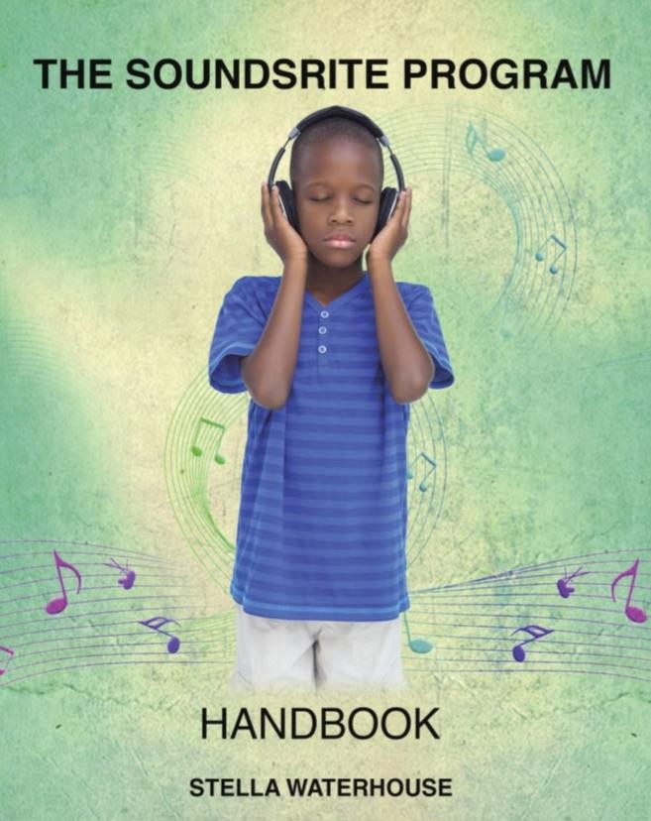

INDEX

INTRODUCTION
- Auditory Integration Training/AIT)
- The Soundsrite© Program
- Potential Benefits
- Research
CANDIDATES for AUDITORY TRAINING
- Auditory Differences
- Autistic Spectrum Disorders
- Anxiety
SPECIAL PRECAUTIONS
The SOUNDSRITE© Program
- Prior To Use
- General Points
- Possible Side Effects.

NOTES
FREQUENTLY ASKED QUESTIONS
APPENDIX - Glue Ear

INTRODUCTION

AUDITORY INTEGRATION TRAINING (AIT) is a ten-day treatment that was initially developed by the late Dr. Guy Bérard, an accomplished Ear, Nose and Throat (ENT) specialist, whose work has touched and enhanced the lives of many people over the decades.
Dr Bérard used AIT successfully in his practice in France for over 25 years, treating people with a wide range of hearing distortions which he had found were contributory factors in a variety of disorders including dyslexia, Attention Deficit/Hyperactivity Disorder, autism or Asperger’s Syndrome (also known as Autistic Spectrum Disorders or ASD).
The use of AIT for people with ASD first gained widespread attention after the publication of The Sound Of A Miracle by Annabel Stehli in which she detailed Dr Bérard’s successful treatment of her daughter Georgiana.
Georgie, as she was known, had a variety of sensory problems but the worst of all was her hypersensitivity to sound: something that scared her so much that, as her mother said, ‘it drove her crazy’. Nor is Georgie alone in that for most people with ASD share similarly severe reactions to auditory and other sensory stimuli.

AIT is now widely used in the USA where it has helped many children and adults, who have underlying difficulties with auditory processing and hearing.
See Dr. Bérard’s book Hearing Equals Behavior for more details.

STELLA WATERHOUSE first became interested in autism in the late 1960s when she met three very different children all of whom shared the same diagnosis: autism.
After training as a Steiner teacher in ‘curative education’ in the 1970s Stella went on to work with children with a variety of disabilities for several years before ‘sidestepping’ to work in residential care with ‘emotionally disturbed’ adolescent boys at the Cotswold Community near Cirencester in the UK.
She returned to her roots in the mid-1980s as Senior Care Officer at a residential home for around 40 adults with ASD - where she became Deputy Principal - working with people whose problems ranged from mild to very severe.
Stella began to research and write books about ASD in the late 1980s and, during that research, became interested in the sensory differences which she believes are an integral part of ASD. That led her to recognize her own sensory problems (especially hyperacusis and some visual problems) which, whilst mild, were quite physically debilitating at times.
She went on to train as an AIT therapist in the 1990s after which she successfully corrected her own hyperacusis, as well as treating a number of children and adults, most of whom had ASD.
She remains passionate about finding ways to enhance the lives of people with such sensory differences - hence the development of the SOUNDSRITE© Program - whilst still finding time to continue her research and writing.

THE SOUNDSRITE© Program
This combines Dr Guy Bérard’s ideas with Stella’s knowledge of the Autistic Spectrum and sensory differences as well as her personal experience of hyperacusis. Thus, in contrast to some other Auditory Integration Training courses, the SOUNDSRITE© sessions begin at a very low level which gradually increases in volume as the course progresses.
In the past access to Auditory Integration Training (AIT) has been limited, partly because of the expense and partly because it often entailed traveling to a ‘treatment center’ - often miles from home. The SOUNDSRITE© Program is much more accessible, being a home-based program that can be used at your convenience.
It must be noted that, for many people, the end of the course provides a new beginning, which is especially important for anyone who has missed out on the usual developmental milestones and/or opportunities for learning in their early years. Thus, the SOUNDSRITE Handbook also include advice on Aftercare which will help consolidate the listener’s progress.

POTENTIAL BENEFITS
As with all types of Auditory Integration Training program, results cannot be guaranteed. Even so most listeners have reported a number of beneficial effects, which though obviously dependent on the individual can include:
- greater tolerance of loud noises and sounds that previously hurt
- reduced stress - feeling calmer and less irritable
- less need to withdraw from situations
- improvements in the ability to listen, concentrate and learn
- increased understanding and improvements in memory
- reduced hypersensitivity to sound
- reduced hyperactivity - less impulsive and distractible
- improved behavior
- clearer speech/improved articulation
- increased communication and sociability
- better eye tracking
- increased confidence and self esteem
- increased ability to take part in - and even enjoy - social experiences
- a reduction in any obsessive/compulsive behaviors

RESEARCH
Various studies have been carried out into AIT one of the most comprehensive being The Efficacy of Auditory Integration Training Jan 1993 – Aug 2004 - by Stephen M. Edelson, Ph. D. and Bernard Rimland, Ph. D. www.autism.com/understanding_ait_summary

WOULD SOUNDSRITE PROGRAM

BE RIGHT FOR MY CHILD

This program can benefit children and adults with attention problems or hyperactivity as well as those with learning difficulties, dyslexia, ASD or pervasive developmental delay. Many of them will have any one (or more) of a variety of auditory difficulties that can have far reaching effects.

In brief the difficulties can include a variety of AUDITORY DIFFERENCES as detailed below:
Poor auditory discrimination. The person may mishear some letters or words or be unable to pin-point where sound is coming from. Such things are quite confusing and, when severe, can even make it sound as if other people are talking nonsense.
Loudness intolerance. The person cannot tolerate the same level of noise as his/her peers, so he/she will get very upset by loud noises such as fire alarms or fireworks.
‘Supersensitive hearing’. Some people can hear noises (or conversations) that others are unaware of (a situation that can be exacerbated by vitamin and mineral deficiencies).
An inability to ‘habituate’. The person cannot block out background sounds which constantly impinge on him/her. This can be very distressing and also causes great stress - making many situations, like mealtimes, almost intolerable.
Hyperacusis - hypersensitivity to sound. This condition can, at times, make specific everyday sounds sound much louder than they actually are. That makes them painful and can make many apparently ordinary situations, like shopping for instance, really difficult and overwhelming.
Hyperacusis means the person is tormented by everyday sounds that most of us ignore or at least tolerate. The sounds that cause problems are individual and can range from quiet sounds like a clock ticking or people eating to louder sounds like vacuum cleaners and food mixers.
People react to hyperacusis in a variety of ways. Some simply block their ears or remove themselves from a particular situation - as with the man who had to go out for a walk every time his wife used the vacuum cleaner. Others react more strongly and, if they are unable to leave the situation which is aggravating their problems, they may quickly become short tempered (and occasionally even agitated or aggressive).

Note: Much of the current literature on hyperacusis has been done with older people who have tinnitus (where most of the research has been done) but it actually affects a wide range of people, some of whom have had the problem since childhood.

Many people with ASD suffer from severe hyperacusis and that, along with their other difficulties, can cause severe effects. Thus, they may withdraw into themselves, suddenly run away from a situation or have a panic attack (which can be mistaken for a tantrum). Such auditory difficulties also:
- make many areas of the home very difficult
- make many social activities like shopping, the playground, classroom or trips out potentially distressing and frightening
- can underlie or aggravate speech and language problems. That is because by tuning out the noises that are painful he/she also misses out on ordinary conversation
- mean that child needs to concentrate much harder than his/her peers in order to make sense of the spoken word – something which can be particularly difficult in noisy situations
- cause acute anxiety

Auditory processing disorder/APD – often referred to as Central Auditory Processing Disorder/CAPD – is a complex problem can leave the person unable to process auditory information correctly.
The symptoms range from mild to severe and can take many different forms. Thus this is the child who:
- Is easily distracted
- Is unusually bothered by loud or sudden noises
- Finds noisy environments upsetting/hard to cope with
- Is better behaved in quiet settings
- Has difficulty following or keeping up in conversations
- Has difficulty following auditory instructions, especially multistage instructions
- Has a speech delay from a young age
- Often misinterprets what is said but doesn’t realize it
- Misses subtle social cues
- Has difficulties with:
  - phonics and learning to read
  - spelling
  - writing
  - speech/language
  - understanding abstract information
- Finds it hard to do verbal math problems
- Is disorganized and/or forgetful

Note: Although such children generally have normal intelligence, if left untreated CAPD/APD may lead to academic deficits.

All those auditory differences can cause - or contribute - to a wide range of effects which include:
- Speech and language delays
- Problems processing auditory information
- Difficulties with ‘listening to learn’
- Difficulties with comprehension
- Poor attention and concentration
- Low self esteem
- Social isolation
- Behavioral problems
- Hyperactivity
- Poor sleep patterns (waking at the slightest noise)

Such auditory differences also underlie some of the other problems associated with the autistic spectrum (commonly abbreviated as ASD) have, including:
- Difficulties with social relationships
- A variety of speech differences – like a monotone voice which lacks expression or speaking very quietly or too loudly

PLEASE NOTE: This Program will NOT cure ASD but it CAN make the person’s life much more comfortable by:
- Eliminating hyperacusis
- Correcting other hearing anomalies
- Enhancing the ability to communicate, socialize and learn

ANXIETY
While the auditory differences already detailed can, in themselves, cause great anxiety there are two specific childhood disorders that need mentioning too.

Selective Mutism.
This is included here because:
- Many of the symptoms are speech related.
- Some children with Selective Mutism also have Sensory Processing Disorder. That leaves them unable to process specific sensory information correctly. Thus like many children with ADHD or ASD they too may be hypersensitive to sounds, lights, touch, taste and smells.
- Some such children also have subtle learning disabilities including auditory processing disorder or language delays.
- Around 20-30% of children with Selective Mutism have subtle speech and/or language abnormalities that could include problems in receptive and/or expressive language.

Those problems can cause them to misinterpret social and environmental cues and can also lead to inflexibility, frustration and anxiety. Anxiety itself may cause the child to:
- ‘Shut down’.
- Avoid and withdraw from a situation
- ‘Act’ out or have tantrums or other negative behaviors

In many cases, the children concerned tend to be introverted and prone to shyness and anxiety. That, plus the added stresses noted above, increase the child’s anxiety and insecurity, especially in situations where they are expected to speak.

Each child is very individual so that the symptoms vary widely but may include the child who:
- is completely mute and not speak at all – even though he/she can
- speaks in a whisper - perhaps to just one or two people
- speaks in the home but not at school
- stands motionless with fear in specific social settings
- seems expressionless and unemotional
- is socially isolated
- is able to socialize with only one/a few children, but is unable to speak or communicate to teachers or most peers

Exposure Anxiety (EA)
Some people with Autistic Spectrum Disorders also suffer from Exposure Anxiety which is similar, but more acute than Social Anxiety and results in symptoms similar to those found in children with Selective Mutism.
Exposure Anxiety can be quite crippling as the child finds any attention from other people potentially threatening. That can have a detrimental effect on the child’s speech and actions and can give rise to a variety of speech ‘differences’. Thus, the child might:
- be mute
- only speak/sing when feeling unobserved
- speak in a whisper
- speak in the home but not at school
- limit his/her speech to a few ‘safe’ words or repetitive phrases (some of which may be seemingly nonsensical)
- ‘freeze’ in specific social settings
- seem expressionless and unemotional
- be socially isolated
- socialize with one/a few children but is unable to speak or communicate with teachers or most peers

SPECIAL PRECAUTIONS

When Using The Soundsrite Program
If the user is prone to ear infections, glue ear,* (see appendix) or excessive wax please ask your doctor to check so that, if necessary, this can be remedied prior to beginning this course.

Please Note:
- This course will be most beneficial if undertaken while there are no added stresses. Anyone undergoing a period of stress like moving to a new house or leaving/moving schools, family problems etc. is strongly advised to delay the start of the course until those stresses have gone.
- It is not necessary to take the child out of school during the course unless you wish to do so.
- Please DO NOT alter or eliminate any ongoing medication during the Program as that will make it difficult to determine how effective the course has been.

SPECIAL PRECAUTIONS
Re using this course with a person who has EPILEPSY
Seizures have a variety of triggers from auditory and visual stimulation to stress. They also tend to be relatively common amongst people with ASD and other developmental disabilities - often appearing in the first few years of life or at the onset of puberty.

As mentioned at the onset, it is recommended that you AVOID this course if auditory stimulation is known to be a trigger factor.
If auditory stimulation is not a known factor and you wish to use the course
please consult your doctor first.

If you decide to proceed please:
- use the course with caution
- use the charts overleaf to detail how often the seizures occur
- keep a careful watch on the listener throughout the Course to see if his/her seizure
activity increases in frequency or duration; noting whether it happens prior
to or after the sessions.

Please note: Stress can also be a trigger factor in the onset of seizures. Using this Program at home will help eliminate much of the stress but it will also help if you try to reduce his/her stress prior to, during and after the auditory session by doing something that the listener finds relaxing.

Prior to beginning make a note of the current seizure pattern

re frequency and duration: i.e. number of times daily, weekly, every other week, once a month, etc. and then fill in the form below during the course

Session | Seizures | Session | Seizures
1 |  | 11
2 |  | 12
3 |  | 13
4 |  | 14
5 |  | 15

6 |  | 16
7 |  | 17
8 |  | 18
9 |  | 19
10 |  | 20

Notes:
The Autism Research Institute in San Diego says it has received many parent reports stating that Vitamin B6 with magnesium and Di-methyl-glycine (DMG) reduced or eliminated seizure activity in their children.
They also state that Vitamin B6 and DMG are much safer than the commonly prescribed anti-seizure drugs. http://www.autism.com/

THE SOUNDSRITE© PROGRAM

PLEASE READ PRIOR TO USE

Use with children or people with ASD
It will be helpful if you can gradually get the person used to over the ear headphones prior to beginning this course. This could be by:
- Encouraging him/her to listen to his/her favorite music through headphones.
- ‘Modeling’ - by listening to music via headphones yourself.
- Using play/puppets/toys as appropriate.

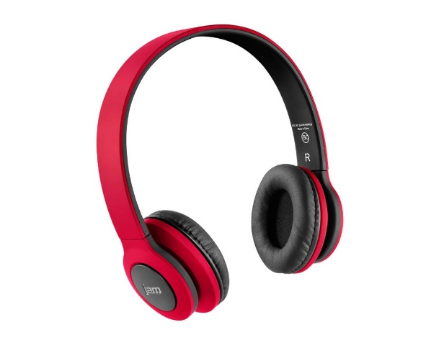

PREPARE THE LISTENER FOR THE COURSE IN ADVANCE.
Generally, once the person realizes that their auditory difficulties have been recognized, they will be happy to use the course.
Where appropriate talk to them about their hearing problems and the potential benefits of the course. However if the child has Exposure Anxiety you may need to broach the subject indirectly using any of the following ideas that you find helpful:
- Talk about the person’s hearing difficulties to someone else - in person or over the phone - when you know they can overhear you, mentioning the fact that you know that those hearing differences cause great problems and realize that it can be quite painful at times and also discussing the potential benefits of the course.
- Repeat this tactic a few times prior to the start of the course.

USING THE PROGRAM

PLEASE:
- Sit in a quiet place where the person will be undisturbed
- ENSURE there is a gap of at least 3 hours between the sessions
- Do not exceed a comfortable listening level (around 80 decibels) as that could damage your hearing.
- Please follow the instructions given at the beginning of each CD and adjust the volume of the introductory piece of music to a comfortable level. The volume will increase a little at the beginning of each subsequent session but do turn it up a little louder if you want to.

Some people with hyperacusis find it most comfortable to start at a relatively low level (which may make the first few sessions barely audible), but if you really need it louder do turn it up.

Note:
During the first few sessions it is highly likely that each one will contain a few of the sounds that the listener dislikes.

If he/she finds this too uncomfortable do turn the sound down briefly - but please remember to increase it again once those sounds have passed.

The first session is often the most difficult for the child as he/she may be unsure what to expect. Where appropriate:
- Let him/her sit on your lap/next to you.
- Use a timer – to show him/her how long it will last.
- Give him/her a reward for listening and use the rewards until the course ends.
- Listen to music via headphones yourself while he/she is listening,
- Keep him/her occupied with a book or quiet toy
- Note: If using the course with a child you may find it useful to note the sound level used in each session.

POSSIBLE SIDE EFFECTS.

Side effects can vary greatly so that many people have none at all while others may experience any - or several - of the following symptoms:
- Excessive tiredness and/or irritability between sessions - especially at the beginning of the course
- A mild headache in the first few days - which may also return for a brief period once the course ends
- Mild dizziness or increased car sickness - particularly around the second day or at the end of treatment
- Increased appetite
- More affectionate
- Feelings of elation/depression/discouragement
- Nervousness
- Aggression – see below**
- On rare occasions a child may actually fall asleep during a session. However this will not alter the beneficial effects as long as he/she keeps the headphones throughout the session.

Note: In people with ASD the physical side effects can give rise to a short term increase in hyperactivity, or obsessive/compulsive behavior. If that happens a mild painkiller may help (although if you haven’t used them before please consult your doctor). Such side effects are generally short lived and indicate that the course is having a beneficial effect.

** Dr Bérard noted that some listeners would suddenly (and unexpectedly) have what he termed, a ‘mental storm’ that could involve:
- Either verbal or physical aggression to those around them
- The use of ‘out of character’ terminology or verbalizations - one example being the well-brought up child who, during dinner with several other people (and much to her mother’s horror), suddenly asked some very blunt questions about her father’s anatomy

Dr Bérard also noted that generally:
- Such behavior was generally very short-lived
- The ‘crisis’ was always minimized (or even completely forgotten), by the listener
afterward
- The more sudden and violent the behavior, the better the end results tended to be

Dr Bérard suggested that in such cases physical restraint should be avoided although mild medication might sometimes be needed – but if in doubt please consult your doctor.

NOTES

You may find it helpful to keep a record of any side effects or any unusual behaviors that happen during the sessions – and their duration.

FREQUENTLY ASKED QUESTIONS

Q. Do I need a hearing test prior to taking the course?
A. While you may choose to have a hearing test both prior to and after this course, it is not a necessity. That’s because general tests are not geared to assessing hyperacusis and the other differences and such children are often found to have good - or even exceptional hearing – so a hearing test is not a good indication of such differences.
However it would be good to use the most appropriate checklist at the back of this booklet as that will indicate whether your child will benefit from Soundsrite.

Q. Can I take a break during the course?
A. Yes. It’s perfectly okay to take a couple of days off midway through the course (after session 10).

Q. What happens if I am ill during the course?
A. That depends on which session you have reached.
- If you are ill before the 10th session and miss less than 5 days just continue the course.
- If you miss more than a week, please take a month’s break and then restart the
course from the beginning.

Q. Medications. Are there any medications that should be avoided?
A. Safe medical treatment as prescribed by a doctor is fine. However, some medications are ototoxic - (toxic to the ear - specifically the cochlea or auditory nerve and sometimes the vestibular system as well). These should be avoided wherever possible.
While your doctor is best placed to advise you Ototoxic medications include Quinine, Sodium salicylate, and antibiotics such as Streptomycin, Kanamycin, Gentamycin and Neomycin.

Q. Does the program have to be repeated more than once?
A. While some practitioners do recommend more than one course in my experience the majority of people only need one course of AIT.

APPENDIX
GLUE EAR is a common childhood condition in which the middle ear becomes filled with fluid (otitis media with effusion). This fluid is often quite thick and may be temporary or persist for many months. It can be very uncomfortable and when severe it can stop the child hearing anything at all.
The most common sign of glue ear is hearing loss, which can affect one or both ears. If your child is struggling to hear, he/she may:
- Have difficulty understanding people who are far away
- Speak quietly
- Appear unusually tired or irritable because he/she has to try harder to listen to things
- Have problems picking out conversations in places where there is a lot of background noise
- Easily "tune out" of conversations when distracted
- Only be able to understand face-to-face conversations that take place at a short distance
- Experience problems with communication, learning and social skills (these problems will usually resolve once hearing is restored to normal)

Less common symptoms of glue ear include:
- Episodes of mild ear pain
- Irritability
- Problems sleeping
- Balance problems and clumsiness
- Tinnitus (hearing a ringing noise in the affected ear or ears)
- Delayed speech and language development (in younger children if it lasts a long time)

CHECKLISTS

MILD - MODERATE AUDITORY DIFFERENCES
- History of hearing loss/ear infections
- Has difficulty following conversations or verbal directions
- Mishears some letters/words and sometimes misunderstands what is said
- Relies on lip-reading, gesture, context - or just plain guessing - to understand what is being said
- Often asks people to repeat things
- Has dyslexia or tinnitus
- Has APD/CAPD - see separate list below
- Has hyperacusis - finds some specific sounds painful. May leave the room or even the house when something noisy like the vacuum cleaner is on
- Often irritable - or loses temper - for no apparent reason
- Light sleeper - wakes easily
- Dislikes or avoids:
  - noisy situations/background noise
  - social contact or interaction
  - concerts
- Enjoys or seeks quiet spaces/places
- Has difficulty taking notes during speech or lecture
- Enjoys constant activity
- Often startled by sudden sound or movement
- Frequently notices sounds before others do
- Sings out of tune - or have difficulty singing with others - may always be a bar behind

CHECKLIST re SEVERE AUDITORY DIFFERENCES - often associated with ASD
These are often particularly noticeable in young children or when they first begin to occur.
- May initially be considered deaf
- Seems to ignore sounds/speech but may hear and recognize the rustle of sweet- papers etc.
- Speech difficulties -
  - speech does not develop (but is not deaf) or development is slow
  - has echolalia
  - speaks clearly but only occasionally; consistently mispronounces some words
  - speaks in a monotone; too loudly; too softly
  - develops speech only for it to deteriorates/disappear either gradually or suddenly
- If given two instructions is only able to carry out one task or does neither
- Dislikes some noises and demonstrates this by:
  - putting hands over/in ears
  - moving (or running) away
  - getting upset or distressed
  - going into ‘a world of his/her own’
- A very light sleeper - wakes easily
- Frightened of some animals – like dogs or cats
- Seems to hear noises which other people might not be aware of - e.g. the hum of fluorescent lights, people breathing etc.
- Can often correctly identify distant noises (before others hear them) or can overhear distant conversations e.g. both sides of a telephone conversation
- Dislike bathing, haircut’s, shaving, teeth cleaning etc. as worried by the noise of the water, scissors, razor etc.
- Dislikes the sound of a toilet flushing
- May finds mealtimes difficult - as dislikes the sound of people eating
- Dislikes/gets upset in shops, crowded situations, shopping, rainstorms, wind, sea etc.
- Learns/concentrates better in quiet surroundings
- Enjoys loud rhythmic noises i.e. Washing machines, vacuum cleaners
- Enjoys being in control of noisy objects - e.g. likes playing with running water, flushing the toilet etc.
- Talks constantly/loudly
- Likes/does things that make a noise; squeaking toys, tearing paper, banging doors etc as being in control of the noise makes it predictable - and it also helps them block out other more unpredictable noises
- Likes listening to music - for the same reasons as above

For more information on autism and Asperger’s syndrome please visit: http://www.autismdecoded.com

Notes:
The SOUNDSRITE© Program was originally recorded at Coombeshead Studios using the BGC device which was developed in the USA by audio engineer Bill Clark.

Dr. Steve Edelson researched the scientific efficacy of the BGC and the original French AudioKinetron in 1992 and found them to be comparable.

Disclaimer
SOUNDSRITE© Program cannot be held responsible for any problems arising from the misuse of the course.

Stella Waterhouse© Updated 2020

